# Assignment: HTTP client and server

A HTTP Server and Client are implemented in this assignment through socket programming. Below are details covering the output screens and explanations.

The client and server programs can be found in the paths:

Client- Dir\Networks\Client\GClient2.java

Server- Dir\Networks\Server\GServer2.java

Test files:

GET- Dir\Networks\Client\GETCHECK.txt

PUT- Dir\Networks\Client\PUTCHECK.txt

PUT- Dir\Networks\Server\PUTCHECK.txt (output)

METHODS:

GET- After server client connection is established via TCP then through this method the client will request server for contents of a file sharing filepath and name, server on receiving this information will respond the client with message “200 OK” or “404 not valid” and also initiates file content transfer, the client then displays the file content.

PUT- In this method after establishing TCP connection client will send a request to share a file with server with information of filepath and filename, the serves then creates a new directory and file then transfers the data from client to the file. The Server sends “200 ok” or “404 not valid” response to client further to the action.

Execution (GET):

Server-

Compiling - javac \Server\GServer2.java

Execution - java Server/GServer2

🡪localhost 7500

Client-

Compiling - javac Client\GClient2.java

Execution - java Client/GClient2

🡪localhost 7500 GET C:/Users/gandhiamar2/Desktop/Networks/Client/GETCHECK.txt

Server output (GET)-

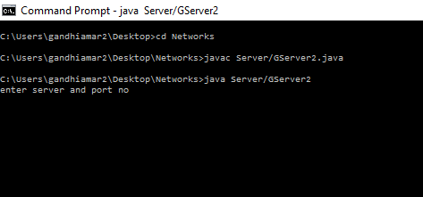

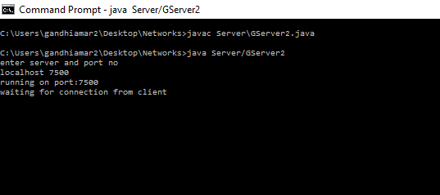

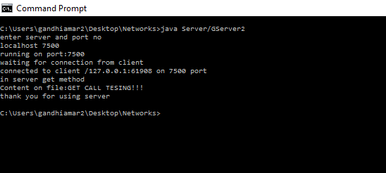

Client Output (GET)-

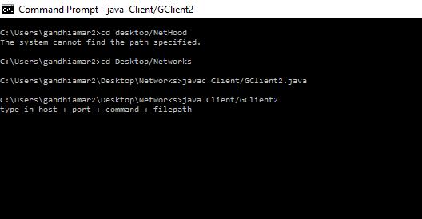

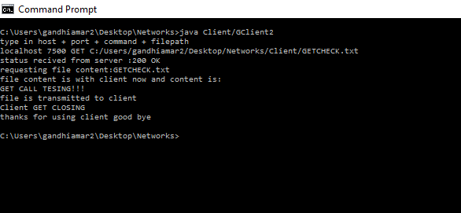

Execution (PUT):

Server-

Compiling - javac \Server\GServer2.java

Execution - java Server/GServer2

🡪localhost 7500

Client-

Compiling - javac Client\GClient2.java

Execution - java Client/GClient2

🡪localhost 7500 PUT C:/Users/gandhiamar2/Desktop/Networks/Client/PUTCHECK.txt

Server Output (PUT)-





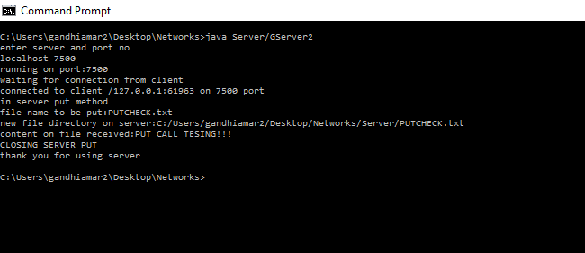

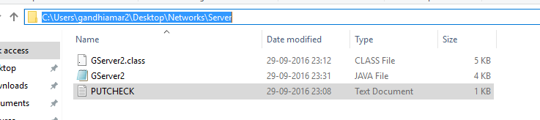

Client Output (PUT)-



